CREATE TABLE public.ref_type (

id INTEGER NOT NULL,

name VARCHAR(13),

CONSTRAINT ref_type_pkey PRIMARY KEY(id)

)

WITH (oids = false);

ALTER TABLE public.ref_type

OWNER TO postgres;

CREATE TABLE public.object (

id SERIAL,

type_id INTEGER,

parent_id INTEGER,

CONSTRAINT object_pkey PRIMARY KEY(id),

CONSTRAINT object_fk FOREIGN KEY (parent_id)

REFERENCES public.object(id)

ON DELETE RESTRICT

ON UPDATE RESTRICT

NOT DEFERRABLE,

CONSTRAINT object_fk1 FOREIGN KEY (type_id)

REFERENCES public.ref_type(id)

ON DELETE RESTRICT

ON UPDATE RESTRICT

NOT DEFERRABLE

)

WITH (oids = false);

ALTER TABLE public.object

OWNER TO postgres;

CREATE TABLE public.area_changing (

id SERIAL,

val_1 REAL,

val_2 REAL,

changing_dt DATE,

obj_id INTEGER,

area REAL,

CONSTRAINT area_changing_pkey PRIMARY KEY(id),

CONSTRAINT area_changing_fk FOREIGN KEY (obj_id)

REFERENCES public.object(id)

ON DELETE RESTRICT

ON UPDATE RESTRICT

NOT DEFERRABLE

)

WITH (oids = false);

ALTER TABLE public.area_changing

OWNER TO postgres;

CREATE OR REPLACE FUNCTION public.a (

p_date date = '2021-09-01'::date

)

RETURNS TABLE (

id integer,

area real,

type text,

level text

) AS

$body$

DECLARE

BEGIN

return query

WITH RECURSIVE r AS (

SELECT po.id,

po.type_id as type,

po.id::text as level

FROM public.object as po

WHERE po.parent_id is null

UNION

SELECT o.id,

o.type_id as type,

r.level || '.' || o.id as level

FROM public.object as o

JOIN r ON o.parent_id = r.id)

SELECT r.id, area.area, rt.name::text, r.level

FROM r

left join public.ref_type rt on rt.id = r.type

left join lateral (select ac.area from public.area_changing ac where ac.obj_id = r.id ORDER by ac.changing_dt desc limit 1 )as area on true

order by r.level;

END;

$body$

LANGUAGE 'plpgsql'

VOLATILE

CALLED ON NULL INPUT

SECURITY INVOKER

PARALLEL UNSAFE

COST 100 ROWS 1000;

ALTER FUNCTION public.a (p_date date)

OWNER TO postgres;

CREATE OR REPLACE FUNCTION public.b (

p_date date

)

RETURNS TABLE (

id integer,

type text,

area real

) AS

$body$

DECLARE

BEGIN

return Query

select onlycircle.id, rt.name::text, area.area::REAL

from (

select *

from public.object o

where o.type_id = 2

) as onlycircle

join public.object op on op.id = onlycircle.parent_id and op.type_id = 1

left join public.ref_type rt on rt.id = onlycircle.type_id

left join lateral

(

select ac.area

from public.area_changing ac

where ac.obj_id = onlycircle.id

ORDER by ac.changing_dt desc

limit 1

) as area on true ;

END;

$body$

LANGUAGE 'plpgsql'

VOLATILE

CALLED ON NULL INPUT

SECURITY INVOKER

PARALLEL UNSAFE

COST 100 ROWS 1000;

ALTER FUNCTION public.b (p_date date)

OWNER TO postgres;

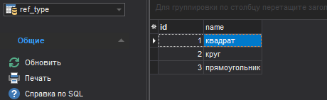

select *

from public.a('01.09.2021')

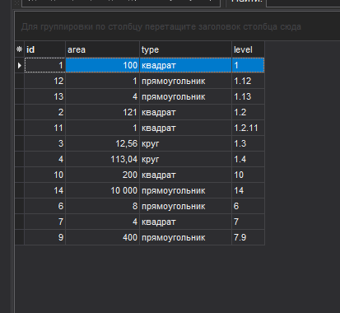

Level добавлен для удобности анализа данных и сортировки по нему (path)

select *

from public.b('01.09.2021')

